WHITE PAPER
ETHICS (JUSTICE)

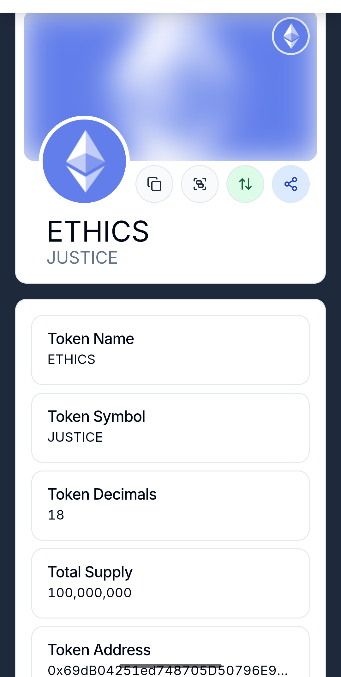
ETHICS (JUSTICE)

- Introduction
Overview: What is ETHICS (JUSTICE)?
ETHICS (JUSTICE) is an innovative crypto token that aims to promote a just and harmonious future. Embodying the principles of love, respect, and empathy, our token strives to create a world where solidarity, cooperation, and peace are at its core.
Purpose and Vision
The vision of ETHICS (JUSTICE) is to create a platform that brings people and communities together to promote a better society. Our goal is to strengthen the values of democracy, human rights and education to ensure the well-being of all. We believe in the power of science, research and creativity to find solutions to the challenges of our time.
ETHICS (JUSTICE) is committed to respecting human rights and the rights of all living beings, including animals. We recognize the ethical responsibility we have towards all creatures and nature. The protection of plants and the promotion of biodiversity are also central concerns that we actively support in order to ensure a balanced and sustainable ecosystem.
We are also committed to environmental sustainability and the protection of natural resources. Our token promotes climate protection, nature conservation and environmental protection to ensure a healthy and livable earth for future generations.
Another important aspect of our vision is the exploration of habitable planets in the universe. We believe that space exploration and the search for new, habitable worlds are part of our responsibility as humanity. This includes the development of sustainable technologies that can be applied not only on Earth but also in other parts of the universe.
To spread these values, we also rely on the power of literature, art and music. These creative expressions have the potential to create deeper emotional connections and raise awareness of social and environmental issues. We encourage artists and writers to use their talents to reflect and promote the principles of ETHICS (JUSTICE) in their works.
With
ETHICS (JUSTICE) we want to address specific societal problems that burden humanity:
No war**: We are committed to peace and conflict resolution through dialogue and cooperation.
No weapons**: We promote a world without violence and are committed to disarmament and the reduction of arsenals.
No arguments**: Through education and empathy, we strive for harmonious communication and conflict resolution.
No crime**: We support social programs that prevent crime and aim at reintegration.
No racism and no discrimination**: We fight against prejudice and stand up for equality and justice, regardless of origin, gender or faith.
No fanaticism**: We promote tolerance, respect and intercultural dialogue to counteract extremism.
We believe in peaceful and harmonious, solidarity-based cooperation based on the ethical principles of ETHICS (JUSTICE). Together we can shape a better future.

- Background
Market Analysis
The cryptocurrency landscape has rapidly gained in importance in recent years. More and more people are recognizing the potential of blockchain technologies and digital assets to address societal, economic, and environmental challenges. Despite the volatility and uncertainties in this space, the demand for innovative and ethical crypto solutions continues unabated. ETHICS (JUSTICE) is entering the market as a new token that not only enables financial transactions, but also brings a deeper, ethical dimension to the crypto world. Our token aims to promote values beyond monetary gain and support a sustainable and equitable future.
Target group
The target group of ETHICS (JUSTICE) is diverse and includes:
Socially committed people**: People who want to actively participate in a just and harmonious society and are interested in social change.
Environmentally conscious**: Individuals who are committed to environmental sustainability and the protection of the environment and are looking for ways to reflect their values in financial investments as well.
Artists and creatives**: People who use art, literature and music to spread messages of peace, solidarity and cooperation.
People interested in education**: People who value education, science and research and who are committed to an informed and enlightened society.
Intergenerational**: Anyone interested in a peaceful, solidarity-based and ecological future, from young people to experienced citizens.
ETHICS (JUSTICE) is aimed at all those who want to contribute to a positive change in the world and strive for a just, harmonious and sustainable future. By using blockchain technology and the transparency and security that comes with it, we are creating a new way to promote and live these values.

- Technical Details
Technology: Ethereum
ETHICS (JUSTICE) is based on the Ethereum blockchain, one of the most widely used and established platforms for the development of decentralized applications (dApps) and smart contracts. Ethereum offers a robust infrastructure that makes it possible to conduct secure and transparent transactions while providing the flexibility to develop innovative solutions.
Token Standard: ERC-20
Our token follows the ERC-20 standard, which is a widely used protocol for creating fungible tokens on the Ethereum blockchain. This standard ensures that ETHICS (JUSTICE) is interoperable with other ERC-20 tokens and dApps. Using the ERC-20 standard allows us to take advantage of the Ethereum community, including integration with wallets, exchanges, and other blockchain services.
Token Contracts: Smart Contracts
The functioning of ETHICS (JUSTICE) is made possible by smart contracts. These self-executing contracts are encoded in the blockchain and automatically regulate the conditions for transactions and token distribution. Smart contracts offer several advantages:
Transparency**: All transactions and conditions are publicly visible and immutable, which creates trust and security.
Automation**: Smart contracts eliminate the need for middlemen, making transactions faster and more cost-effective.
Reliability**: The coded terms guarantee that all transactions are carried out according to the established rules.
By combining Ethereum technology, the ERC-20 standard, and smart contracts, ETHICS (JUSTICE) provides a secure, transparent, and efficient solution to advance our ethical values and support a just, ecological future.

- Tokenomics
Token Distribution
The distribution of the ETHICS (JUSTICE) tokens will follow a transparent and fair model to ensure that the interests of all stakeholders are taken into account. The distribution is as follows:
Public Sale (ICO)**: 50% of the total amount of tokens will be sold to the public via an Initial Coin Offering (ICO). This enables interested parties to invest in the project at an early stage and become part of the movement.
Team and Development**: 20% of the tokens are reserved for the development team and founders. These tokens come with a vesting period to ensure that the team remains committed for the long term.
Community and Marketing**: 15% of the tokens will be used for marketing and community engagement activities to spread the word about the project and build an active user base.
Reserves and partnerships**: 10% of the tokens are held in a reserve fund for strategic partnerships and future developments.
Social projects**: 5% of the tokens are dedicated to initiatives that support social and environmental projects that are in line with the values of ETHICS (JUSTICE).
Use Cases
ETHICS (JUSTICE) offers a variety of use cases that are relevant both inside and outside the token system:
Transactions**: Users can use ETHICS (JUSTICE) tokens to exchange goods and services within the ETHICS community.
Donations and crowdfunding**: The token can be used to support projects that promote social justice, environmental protection, and education.
Rewards**: Users who actively contribute to the community or support positive social initiatives can be rewarded with ETHICS (JUSTICE) tokens.
Access to content**: Artists, authors, and scholars can offer exclusive content and events that are only accessible with ETHICS (JUSTICE) tokens.
Economic model
The economic model of ETHICS (JUSTICE) is based on the creation of a sustainable ecosystem that benefits both users and the community:
Sustainable value creation**: By promoting social and environmental projects, the token system generates long-term value by initiating positive change in society.
Interaction and engagement**: Users who actively participate in the community are incentivized, which promotes user retention and growth of the platform.
Partnerships**: Strategic partnerships with organizations and companies that share similar values will allow the network to grow and increase token utility value.
Transparency and trust**: The use of blockchain technology creates a high level of transparency and trust, which promotes the acceptance and use of the token.
Through this tokenomics, ETHICS (JUSTICE) becomes a tool for positive change and promoting a just, harmonious and sustainable future.

- Roadmap
Development Plan
The roadmap of ETHICS (JUSTICE) outlines the most important milestones we want to achieve in order to achieve our goal of a just and harmonious future. Here are the planned steps:
Q1 2025**:
Market research and community building: Conducting comprehensive market analysis and building an engaged community through social media and public events.
Creation of the whitepaper: Finalization and publication of the whitepaper to present the vision, mission, and technical details of the token.
Q2 2025**:
Website launch: Launch of the official website for ETHICS (JUSTICE) to provide information, updates and resources.
Token Presale: Conducting a presale for early investors to secure capital for development and marketing.
June 2025**:
Token launch: Official launch of ETHICS (JUSTICE) on the Ethereum blockchain. The token will be available for buying, selling, and using within the community.
Q3 2025**:
Listing on crypto exchanges: Targeting listings on multiple crypto exchanges to increase liquidity and access to the token.
Social responsibility initiatives: Launching programs and partnerships that support social justice and environmental projects.
Q4 2025**:
Expansion of community engagement initiatives: Organizing events, workshops and webinars to promote awareness of the values of ETHICS (JUSTICE).
Feedback and customizations: Gathering feedback from the community and customizing the token and platform based on users' needs.
2026 and beyond**:
Long-term partnerships: Building strategic partnerships with organizations and companies that share similar values to further expand the network and the use of the token.
Expanding use cases: Developing new features and use cases for ETHICS (JUSTICE) to keep providing users with new ways to interact and engage.
This roadmap ensures that we are on the right track to realize the vision of ETHICS (JUSTICE) and bring about positive change in the world.

- Team
Geologist Haydar Toraman
Haydar Toraman is the founder and main initiator of ETHICS (JUSTICE). With a diploma in geology, he brings a sound scientific background and a passion for sustainability and environmental awareness to the project. His experience in research and development enables him to analyze complex problems and find innovative solutions.
Overview of Haydar Toraman:
Academic Qualifications**: Graduate Geologist, specializing in ecological issues and resource conservation.
Visionary Leadership**: Haydar believes in the need to integrate ethical values into the world of cryptocurrencies to create a more just and harmonious society.
Commitment to social and ecological issues**: He is actively involved in the protection of the environment, human rights and the promotion of education and science.
Haydar strives to gather a dedicated team of professionals who share the values of ETHICS (JUSTICE). In the upcoming phases, the team will be expanded to include experts from various fields, including blockchain technology, marketing, social sciences, and the arts, to bring a broad and diverse perspective to the project.
Together, the team will work to put the vision of ETHICS (JUSTICE) into action and promote positive change in society.

- The
legal framework for cryptocurrencies and blockchain projects is complex and varies by country and region. ETHICS (JUSTICE) attaches great importance to compliance with all relevant legal regulations and regulatory requirements. Here are some key considerations:
Legal classification:
We are looking into whether ETHICS (JUSTICE) is classified as a security or a utility token. This depends on the specific features and use cases of the token. A clear legal classification is crucial for compliance.
KYC/AML Requirements:
To ensure the integrity of the platform and prevent money laundering and fraud, we will implement KYC (Know Your Customer) and AML (Anti-Money Laundering) procedures. This means that users must provide personal information when registering.
Privacy Policy:
The protection of our users' personal information is of paramount importance. We will ensure that all data protection regulations, such as the EU General Data Protection Regulation (GDPR), are complied with.
Tax aspects:
Users should be aware that profits from trading cryptocurrencies are taxable in many countries. We recommend that you find out about the local tax obligations and seek legal advice if necessary.
Transparent communication:
ETHICS (JUSTICE) is committed to transparent communication about all aspects of the project, including the risks and opportunities, in order to increase the trust of the community.
International Compliance:
As ETHICS (JUSTICE) aims to appeal to a global community, we will strive to comply with all international regulations and guidelines to enable widespread adoption and use of the token.
By carefully considering these legal aspects, we strive to create a safe and trustworthy environment for all users of ETHICS (JUSTICE). We are committed to proactively responding to all regulatory developments and ensuring that our project meets the highest standards of compliance.

- Result
Summary of the vision
ETHICS (JUSTICE) is more than just a crypto token; it is a movement that works for a just, harmonious and sustainable future. Our vision is based on the principles of love, respect, empathy and solidarity and aims to create a world where peace, freedom and human rights are respected for all people and living beings.
By integrating ecological values, protecting biodiversity, and exploring habitable planets in the universe, we strive to provide a comprehensive solution to the challenges of our time. We believe in the power of art, literature and music to spread our message and drive positive change.
ETHICS (JUSTICE) places a strong emphasis on legal compliance and user protection, while leveraging innovative technologies such as the Ethereum blockchain and smart contracts to ensure transparency and security.
With a clear tokenomics based on fair distribution and sustainable value creation, we are creating an ecosystem that offers both financial and social benefits. Our goal is to build an engaged community that actively participates in realizing this vision.
Together, we can tackle the challenges of our time and create a better future for all. ETHICS (JUSTICE) stands for hope, change and a new era of cooperation — an era where ethical values are central.

9. Contact Information
For more information about ETHICS (JUSTICE) and to become part of our movement, please visit our websites:
http://www.worldethics.info
http://www.worldethik.com
http://www.universalethics.info
http://www.ethicsforeveryone.info
http://www.ethics.watch
http://www.ethics.tips
http://www.ourearth.life
http://www.ouruniverse.live
http://www.helpworld.info
http://www.protectearth.info
We appreciate your interest and support! Together, we can make a positive change in the world.



